Web Technologies
Assignment – 01

Name : Ajay David Samuel
Roll No : 24CS012
Class : III – CSE – A
Course : Web Technologies
Course Code : U21CS501

Question – 01
Scenario: A newly established educational institution plans to launch its official website. Before developing the website, the management wants to understand the fundamental concepts of the World Wide Web.
Task: Create a simple HTML webpage explaining the following concepts with suitable illustrations or diagrams: • Internet Overview • Fundamental Computer Network Concepts • URL and its Structure • Domain Name • Web Browsers and Web Servers • Working Principle of a Website • Difference between Client-side and Server-side Scripting
Code:
index.html:
<!DOCTYPE html>
<html>
<head>
<meta charset="UTF-8">
<title>How the Web Works</title>
<style>
body {
font-family: 'Trebuchet MS', Arial, sans-serif;
margin: 0;
background-color: #f7f8fa;
color: #222;
}
.wrapper { max-width: 900px; margin: auto; padding: 30px; }
h1 {
color: #ffffff;
background-color: #1b2a4a;
text-align: center;
padding: 22px;
margin: 0 0 20px 0;
border-radius: 0 0 10px 10px;
}
h2 {
color: #1b2a4a;
border-bottom: 3px solid #c0392b;
padding-bottom: 6px;
}
.box {
border: 2px solid #c0392b;
background-color: #fdf1ef;
border-radius: 8px;
padding: 16px;
margin: 15px 0;
text-align: center;
font-weight: bold;
}
table { border-collapse: collapse; width: 100%; margin-top: 10px; }
th, td { border: 1px solid #ccc; padding: 10px; }
th { background-color: #1b2a4a; color: white; }
tr:nth-child(even) { background-color: #f0f0f2; }
</style>
</head>
<body>
<h1>How the Web Works</h1>
<div class="wrapper">

<h2>1. The Internet in Brief</h2>
<p>The Internet is the physical and logical network of cables, routers, and satellites that lets
computers around the planet exchange data. The Web is just one of the services built on top of it.</p>
<div class="box">Home Router &rarr; ISP &rarr; Internet Exchange &rarr; Destination Server</div>
<p>Everyday services riding on the Internet include:</p>
<ul>
<li>Web Browsing</li>
<li>Video Calls</li>
<li>Cloud Storage</li>
<li>Online Gaming</li>
<li>Email</li>
</ul>

<h2>2. Networking Building Blocks</h2>
<p>A network is simply devices wired or wirelessly linked so they can talk to one another.</p>
<h3>Key Terms</h3>
<ul>
<li><b>Device / Node:</b> Anything that can send or receive data (laptop, phone, printer).</li>
<li><b>IP Address:</b> The numeric label assigned to a device on a network.</li>
<li><b>Router:</b> Directs traffic between different networks.</li>
<li><b>Access Point:</b> Lets wireless devices join a network.</li>
<li><b>Protocol:</b> The agreed format for exchanging data, e.g. HTTP or FTP.</li>
</ul>
<div class="box">Phone &rarr; Access Point &rarr; Router &rarr; Internet &rarr; Cloud Service</div>

<h2>3. Breaking Down a URL</h2>
<p><b>URL</b> stands for Uniform Resource Locator &mdash; the address typed to reach a resource on the Web.</p>
<div class="box">https://shop.cloudnest.io/deals/summer-sale</div>
<ul>
<li><b>https:</b> Protocol used for the connection</li>
<li><b>shop:</b> Subdomain</li>
<li><b>cloudnest.io:</b> Domain name</li>
<li><b>/deals/summer-sale:</b> Path to the specific page</li>
</ul>

<h2>4. What's in a Domain Name</h2>
<p>A domain name replaces a hard-to-remember IP address with a readable name.</p>
<div class="box">www.greenvalley.org</div>
<ul>
<li><b>www</b> &mdash; Subdomain</li>
<li><b>greenvalley</b> &mdash; Registered name</li>
<li><b>.org</b> &mdash; Top-level domain</li>
</ul>
<h3>Frequently Seen Extensions</h3>
<table>
<tr><th>Extension</th><th>Commonly Used For</th></tr>
<tr><td>.com</td><td>General / commercial sites</td></tr>
<tr><td>.org</td><td>Non-profit organizations</td></tr>
<tr><td>.net</td><td>Network / infrastructure services</td></tr>
<tr><td>.io</td><td>Tech startups and products</td></tr>
<tr><td>.co.in</td><td>Indian commercial entities</td></tr>
</table>

<h2>5. Browsers and Servers</h2>
<h3>Web Browser</h3>
<p>Software that requests a page and displays it to the user &mdash; e.g. Chrome, Firefox, Brave, Safari.</p>
<h3>Web Server</h3>
<p>The machine and software that store site files and reply to browser requests &mdash; e.g. Apache, Nginx, LiteSpeed.</p>
<div class="box">Browser --request--&gt; Server<br>Server --response--&gt; Browser</div>

<h2>6. Journey of a Page Load</h2>
<ol>
<li>Visitor types an address or taps a link.</li>
<li>Browser looks up the domain's IP address using DNS.</li>
<li>Browser opens a connection to that server.</li>
<li>Browser sends an HTTP(S) request for the page.</li>
<li>Server finds the requested files and builds a response.</li>
<li>Server returns the page data to the browser.</li>
<li>Browser paints the HTML, CSS, and JavaScript on the screen.</li>
</ol>
<div class="box">Visitor &rarr; Browser &rarr; DNS &rarr; Server &rarr; Response &rarr; Page Displayed</div>

<h2>7. Client-Side vs Server-Side Scripting</h2>
<table>
<tr><th>Aspect</th><th>Client-Side</th><th>Server-Side</th></tr>
<tr><td>Runs on</td><td>The visitor's device</td><td>The web server</td></tr>
<tr><td>Common language</td><td>JavaScript</td><td>PHP, Python, Java</td></tr>
<tr><td>Good for</td><td>Instant UI feedback</td><td>Business rules & storage</td></tr>
<tr><td>Reaches a database?</td><td>Not directly</td><td>Yes, usually</td></tr>
<tr><td>Typical example</td><td>Live input validation</td><td>Processing a payment</td></tr>
</table>
<div class="box">
Client-Side: Visitor &rarr; Browser &rarr; JS Engine &rarr; Immediate Update<br><br>
Server-Side: Visitor &rarr; Browser &rarr; Server &rarr; Database &rarr; Final Response
</div>

<h2>Summary</h2>
<p>Networks, browsers, servers, domain names and scripting each play a distinct role, and together
they turn a typed address into a rendered page in a fraction of a second.</p>
</div>
</body>
</html>

Output:
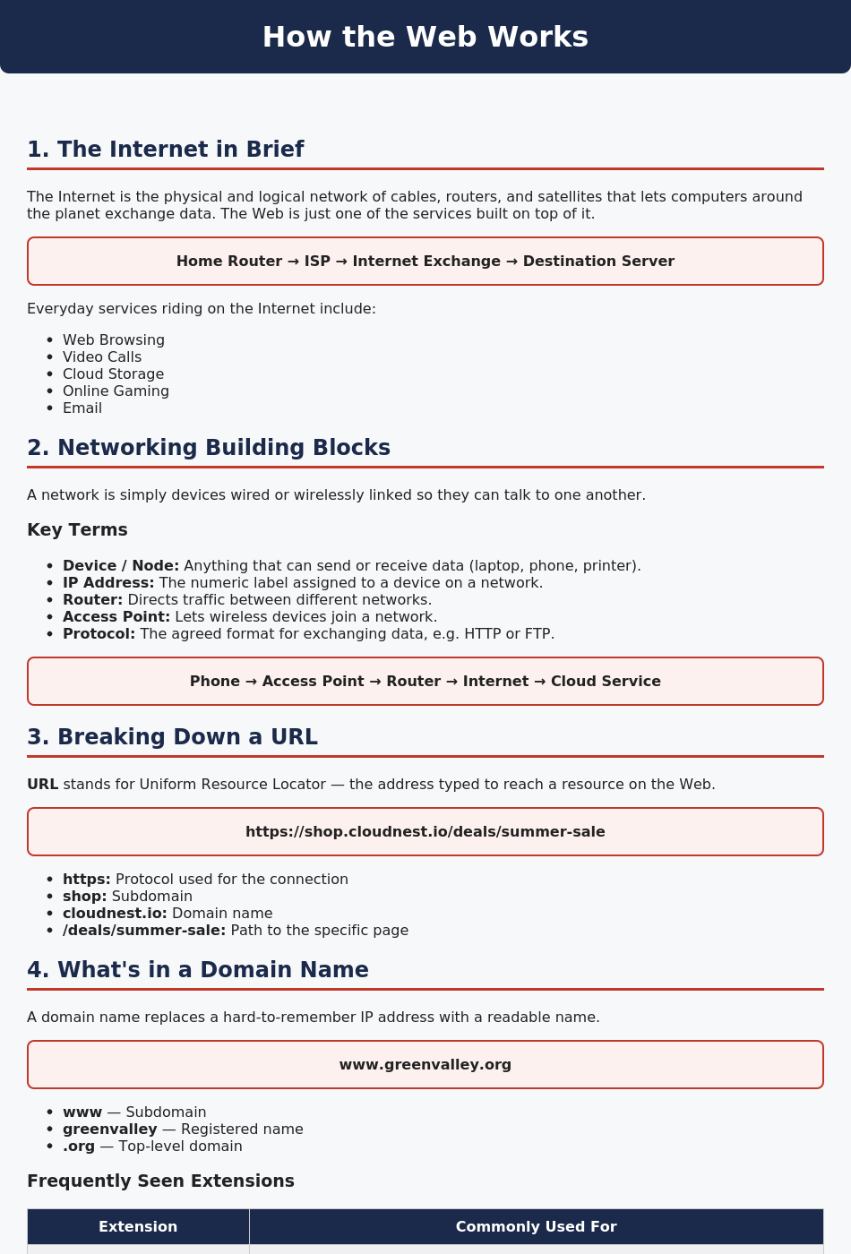
Figure 1.1 Output Page
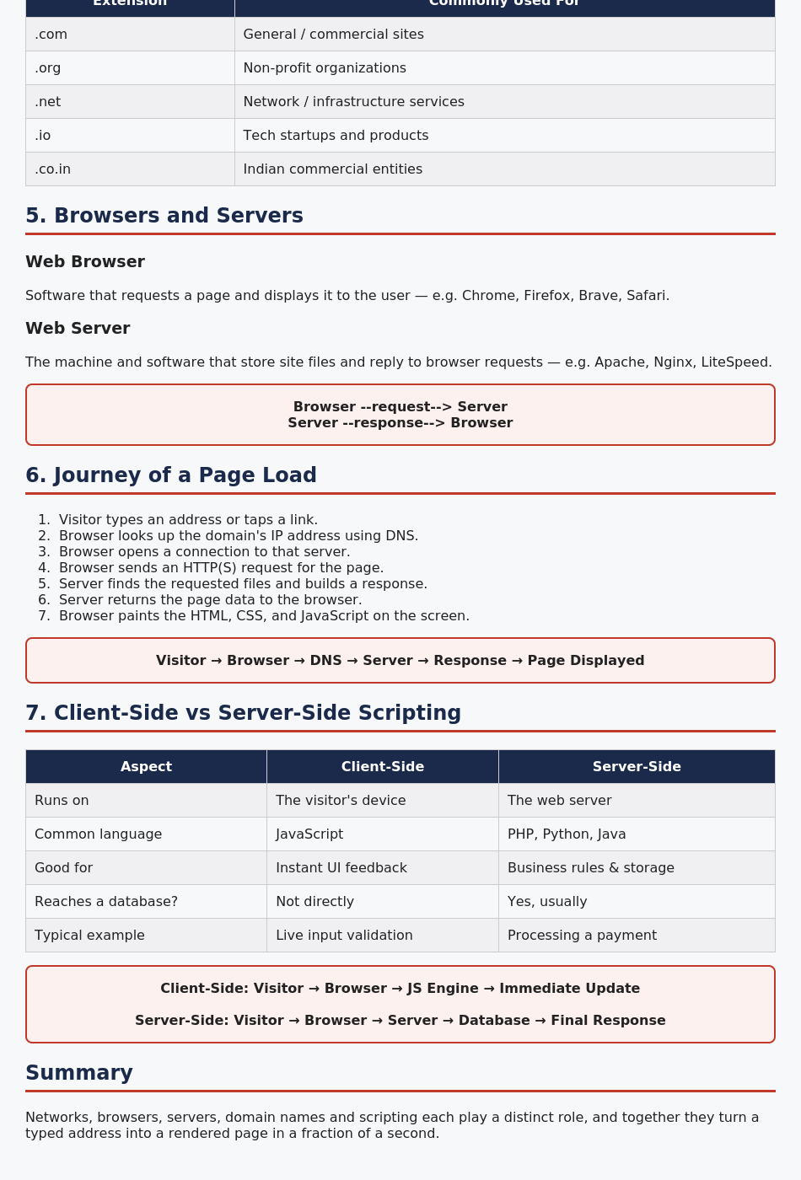
Figure 1.2 Output Page (continued)

Question – 02
Scenario: A public library wants to modernize its membership sign-up process for new readers.
Task: Design a responsive Library Membership Registration Form using HTML5 and CSS3. Your webpage should demonstrate: • HTML Form Elements • Different Input Types • Media Elements (Image/Video/Audio) • CSS3 Selectors • Box Model • Responsive User Interface
Code:
index.html:
<!DOCTYPE html>
<html lang="en">
<head>
<meta charset="UTF-8">
<meta name="viewport" content="width=device-width, initial-scale=1.0">
<title>Library Membership Registration</title>
<link rel="stylesheet" href="style.css">
</head>
<body>
<header>
<h1>Maple Street Public Library</h1>
<p>New Membership Registration</p>
</header>
<main class="container">
<div class="form-header">
<h2>Membership Application Form</h2>
<p>Fill out the details below to get your library card.</p>
</div>
<form>
<section>
<h3>Personal Details</h3>
<div class="row">
<div class="field">
<label for="name">Full Name</label>
<input type="text" id="name" placeholder="Enter your full name" required>
</div>
<div class="field">
<label for="dob">Date of Birth</label>
<input type="date" id="dob" required>
</div>
</div>
<div class="row">
<div class="field">
<label for="email">Email Address</label>
<input type="email" id="email" placeholder="you@example.com" required>
</div>
<div class="field">
<label for="phone">Phone Number</label>
<input type="tel" id="phone" placeholder="Enter phone number" required>
</div>
</div>
<div class="field">
<label>Membership Type</label>
<div class="options">
<label><input type="radio" name="membership" value="student"> Student</label>
<label><input type="radio" name="membership" value="adult"> Adult</label>
<label><input type="radio" name="membership" value="senior"> Senior Citizen</label>
</div>
</div>
</section>

<section>
<h3>Reading Preferences</h3>
<div class="row">
<div class="field">
<label for="genre">Favourite Genre</label>
<select id="genre" required>
<option value="">Select Genre</option>
<option>Fiction</option>
<option>Science &amp; Technology</option>
<option>History</option>
<option>Biography</option>
<option>Children's Books</option>
<option>Comics &amp; Graphic Novels</option>
</select>
</div>
<div class="field">
<label for="cardType">Card Type</label>
<select id="cardType" required>
<option value="">Select Card Type</option>
<option>Standard (5 books/month)</option>
<option>Premium (15 books/month)</option>
<option>Digital Only (e-books)</option>
</select>
</div>
</div>
<div class="row">
<div class="field">
<label for="booksPerMonth">Expected Books per Month</label>
<input type="number" id="booksPerMonth" min="1" max="30" placeholder="e.g. 4">
</div>
<div class="field">
<label for="joinDate">Preferred Start Date</label>
<input type="date" id="joinDate">
</div>
</div>
</section>

<section>
<h3>Address</h3>
<div class="field">
<label for="address">Home Address</label>
<textarea id="address" rows="3" placeholder="Enter your complete address"></textarea>
</div>
<div class="row">
<div class="field">
<label for="city">City</label>
<input type="text" id="city" placeholder="Enter city">
</div>
<div class="field">
<label for="pincode">Pincode</label>
<input type="number" id="pincode" placeholder="Enter pincode">
</div>
</div>
</section>

<section>
<h3>Additional Interests</h3>
<div class="field">
<label>Library Programs You'd Like Updates On</label>
<div class="options">
<label><input type="checkbox" name="program"> Book Clubs</label>
<label><input type="checkbox" name="program"> Author Talks</label>
<label><input type="checkbox" name="program"> Kids' Storytime</label>
<label><input type="checkbox" name="program"> Writing Workshops</label>
</div>
</div>
<div class="field">
<label for="notes">Any Special Requests</label>
<textarea id="notes" rows="3" placeholder="Let us know if you need anything specific"></textarea>
</div>
</section>

<div class="agreement">
<label>
<input type="checkbox" required>
I agree to the library's borrowing rules and return policy.
</label>
</div>
<div class="buttons">
<button type="submit">Submit Application</button>
<button type="reset" class="reset">Clear Form</button>
</div>
</form>
</main>
<footer>
<p>&copy; 2026 Maple Street Public Library | Membership Portal</p>
</footer>
</body>
</html>

style.css:
* { box-sizing: border-box; }
body {
margin: 0;
font-family: 'Georgia', 'Segoe UI', Arial, sans-serif;
background-color: #f6f0ef;
color: #2b2b2b;
}
header {
background-color: #6e1f2a;
color: white;
text-align: center;
padding: 25px;
}
header h1 { margin: 0; font-size: 28px; }
header p { margin: 8px 0 0; font-size: 15px; opacity: 0.9; }

.container {
width: 90%;
max-width: 900px;
margin: 30px auto;
background-color: white;
padding: 30px;
border: 1px solid #ecdcdc;
border-radius: 12px;
box-shadow: 0 3px 12px rgba(0,0,0,0.06);
}
.form-header {
text-align: center;
border-bottom: 2px solid #6e1f2a;
padding-bottom: 18px;
margin-bottom: 22px;
}
.form-header h2 { margin: 0; color: #6e1f2a; font-size: 24px; }
.form-header p { color: #666; }

section {
margin-bottom: 22px;
padding: 18px;
border: 1px solid #ecdcdc;
border-radius: 8px;
background-color: #fdfafa;
}
section h3 {
margin-top: 0;
color: #6e1f2a;
border-left: 4px solid #c9a227;
padding-left: 10px;
}
.row { display: flex; gap: 20px; }
.field { flex: 1; margin-bottom: 14px; }
.field label { display: block; font-weight: bold; margin-bottom: 6px; font-size: 14px; }

input[type="text"], input[type="email"], input[type="tel"], input[type="number"],
input[type="date"], select, textarea {
width: 100%;
padding: 10px;
border: 1px solid #d9c2c2;
border-radius: 5px;
font-size: 14px;
}
input:focus, select:focus, textarea:focus {
outline: none;
border-color: #6e1f2a;
}
.options { display: flex; gap: 18px; flex-wrap: wrap; }
.options label { font-weight: normal; }
.options input { margin-right: 5px; }

.agreement {
margin: 18px 0;
padding: 14px;
background-color: #fbf3de;
border: 1px solid #ecdca4;
border-radius: 5px;
}
.agreement label { font-weight: normal; }

.buttons { text-align: center; }
button {
padding: 12px 28px;
margin: 5px;
border: none;
border-radius: 5px;
background-color: #6e1f2a;
color: white;
font-size: 15px;
cursor: pointer;
}
button:hover { background-color: #531621; }
button.reset { background-color: #888; }
button.reset:hover { background-color: #666; }

footer {
background-color: #6e1f2a;
color: white;
text-align: center;
padding: 14px;
margin-top: 30px;
}

@media screen and (max-width: 700px) {
.container { width: 95%; padding: 15px; }
.row { flex-direction: column; gap: 0; }
header h1 { font-size: 22px; }
section { padding: 14px; }
}

Output:
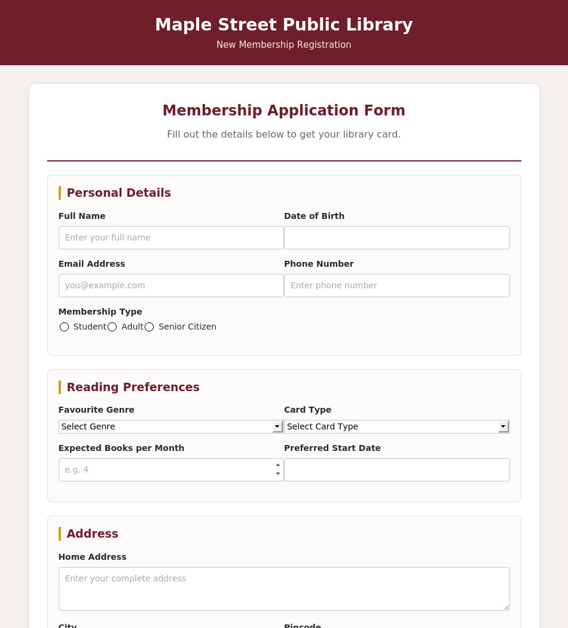
Figure 2.1 Output Page
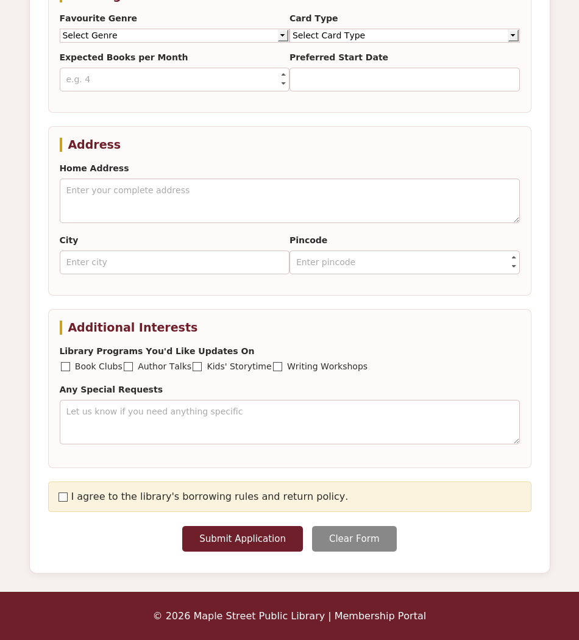
Figure 2.2 Output Page (continued)

Question – 03
Scenario: An online electronics retailer wants an attractive home page to improve customer engagement.
Task: Design the homepage using HTML5 and CSS3 by incorporating: • Backgrounds and Borders • Text Effects • CSS Animations • Multiple Column Layout • User Interface Design Principles
Code:
index.html:
<!DOCTYPE html>
<html lang="en">
<head>
<meta charset="UTF-8">
<meta name="viewport" content="width=device-width, initial-scale=1.0">
<title>Electro Bay - Electronics Store</title>
<link rel="stylesheet" href="style.css">
</head>
<body>
<header>
<div class="logo">Electro Bay</div>
<nav>
<a href="#">Home</a>
<a href="#">Laptops</a>
<a href="#">Audio</a>
<a href="#">Smart Home</a>
<a href="#">Deals</a>
<a href="#">Support</a>
</nav>
<button class="cart">Cart</button>
</header>

<section class="hero">
<div class="hero-text">
<p class="offer">TECH FEST 2026</p>
<h1>Power Up Your World</h1>
<p>Top brands, honest prices, and same-day dispatch on every order.</p>
<button class="shop">Shop Now</button>
</div>
</section>

<section class="categories">
<h2>Shop By Category</h2>
<div class="category-container">
<div class="category">
<div class="category-icon">&#128187;</div>
<h3>Laptops</h3>
<p>Everyday, gaming and creator machines.</p>
<button>Explore</button>
</div>
<div class="category">
<div class="category-icon">&#127911;</div>
<h3>Audio</h3>
<p>Headphones, earbuds and speakers.</p>
<button>Explore</button>
</div>
<div class="category">
<div class="category-icon">&#128161;</div>
<h3>Smart Home</h3>
<p>Lighting, plugs and voice assistants.</p>
<button>Explore</button>
</div>
</div>
</section>

<section class="products">
<h2>Trending This Week</h2>
<div class="product-container">
<div class="product">
<div class="product-image laptop">&#128187;</div>
<h3>AeroBook 14</h3>
<p>Slim everyday laptop</p>
<h4>&#8377;54,999</h4>
<button>Add to Cart</button>
</div>
<div class="product">
<div class="product-image earbuds">&#127911;</div>
<h3>PulsePods Air</h3>
<p>Wireless noise-cancelling earbuds</p>
<h4>&#8377;3,499</h4>
<button>Add to Cart</button>
</div>
<div class="product">
<div class="product-image speaker">&#128266;</div>
<h3>BoomCube Mini</h3>
<p>Portable Bluetooth speaker</p>
<h4>&#8377;2,199</h4>
<button>Add to Cart</button>
</div>
<div class="product">
<div class="product-image bulb">&#128161;</div>
<h3>GlowSmart Bulb</h3>
<p>Wi-Fi enabled colour bulb</p>
<h4>&#8377;899</h4>
<button>Add to Cart</button>
</div>
</div>
</section>

<section class="discount">
<h2>Tech Fest Sale!</h2>
<p>Get up to <strong>35% OFF</strong> on selected electronics.</p>
<button>View Deals</button>
</section>

<footer>
<h3>Electro Bay</h3>
<p>Your trusted destination for everyday tech.</p>
<p>&copy; 2026 Electro Bay Electronics</p>
</footer>
</body>
</html>

style.css:
* { box-sizing: border-box; margin: 0; padding: 0; }
body {
font-family: 'Segoe UI', Arial, sans-serif;
color: #1c2b36;
background-color: #f2f7fa;
}
header {
background-color: #0b1e33;
color: white;
padding: 18px 6%;
display: flex;
align-items: center;
justify-content: space-between;
border-bottom: 3px solid #17b6c9;
}
.logo { font-size: 26px; font-weight: bold; letter-spacing: 1px; }
nav a { color: white; text-decoration: none; margin: 0 12px; font-size: 15px; }
nav a:hover { color: #17b6c9; }
.cart {
background-color: #17b6c9;
color: #0b1e33;
border: 2px solid white;
padding: 9px 15px;
border-radius: 20px;
cursor: pointer;
font-weight: bold;
}

.hero {
height: 420px;
background: linear-gradient(to right, #0b1e33, #143a58);
display: flex;
align-items: center;
padding-left: 8%;
color: white;
border-bottom: 5px solid #17b6c9;
}
.hero-text { max-width: 550px; animation: slideIn 1.4s ease; }
.offer { color: #17b6c9; font-weight: bold; letter-spacing: 3px; margin-bottom: 15px; }
.hero h1 { font-size: 50px; margin-bottom: 15px; text-shadow: 2px 2px 5px rgba(0,0,0,0.5); }
.hero p { font-size: 17px; line-height: 1.6; }

.shop, .discount button {
margin-top: 25px;
padding: 13px 30px;
background-color: #17b6c9;
color: #0b1e33;
border: none;
border-radius: 25px;
font-size: 16px;
font-weight: bold;
cursor: pointer;
}
.shop:hover, .discount button:hover { background-color: #129aab; transform: scale(1.05); }

.categories, .products { padding: 50px 7%; text-align: center; }
.categories h2, .products h2 { font-size: 32px; margin-bottom: 30px; color: #0b1e33; }
.category-container { display: flex; gap: 25px; justify-content: center; }
.category {
background-color: white;
border: 1px solid #dbeaf0;
border-radius: 12px;
padding: 25px;
width: 30%;
box-shadow: 0 3px 10px #e0eef3;
transition: 0.3s;
}
.category:hover { transform: translateY(-8px); border-color: #17b6c9; }
.category-icon { font-size: 52px; margin-bottom: 15px; }
.category h3 { margin-bottom: 10px; color: #0b6478; }
.category p { margin-bottom: 15px; color: #5a6b74; }
.category button {
padding: 8px 20px;
border: 1px solid #0b6478;
background-color: white;
color: #0b6478;
border-radius: 20px;
cursor: pointer;
}

.product-container { display: flex; flex-wrap: wrap; gap: 20px; }
.product-container .product { flex: 1 1 21%; }
.product {
background-color: white;
border: 1px solid #dbeaf0;
padding: 15px;
border-radius: 10px;
transition: 0.3s;
}
.product:hover { transform: translateY(-5px); box-shadow: 0 5px 15px #cfe4ea; }
.product-image {
height: 170px;
display: flex;
align-items: center;
justify-content: center;
font-size: 70px;
border-radius: 8px;
margin-bottom: 15px;
}
.laptop { background-color: #e5f4f7; }
.earbuds { background-color: #eaf2fb; }
.speaker { background-color: #eef4e6; }
.bulb { background-color: #fdf5e3; }
.product h3 { margin-bottom: 8px; }
.product p { color: #6b7b84; font-size: 14px; }
.product h4 { color: #0b6478; font-size: 20px; margin: 12px; }
.product button {
width: 100%;
padding: 10px;
border: none;
background-color: #0b1e33;
color: white;
border-radius: 5px;
cursor: pointer;
}
.product button:hover { background-color: #17b6c9; color: #0b1e33; }

.discount {
background: linear-gradient(120deg, #0b6478, #17b6c9);
color: white;
text-align: center;
padding: 50px;
margin: 20px 7%;
border-radius: 15px;
animation: pulse 3s infinite;
}
.discount h2 { font-size: 34px; margin-bottom: 10px; }
.discount p { font-size: 18px; }

footer {
background-color: #0b1e33;
color: white;
text-align: center;
padding: 30px;
margin-top: 40px;
}
footer h3 { color: #17b6c9; font-size: 22px; margin-bottom: 10px; }
footer p { margin: 5px; color: #b7c6ce; }

@keyframes slideIn {
from { opacity: 0; transform: translateX(-60px); }
to { opacity: 1; transform: translateX(0); }
}
@keyframes pulse {
0% { transform: scale(1); }
50% { transform: scale(1.02); }
100% { transform: scale(1); }
}

@media screen and (max-width: 800px) {
header { flex-direction: column; gap: 15px; }
.hero { height: 380px; padding: 30px; text-align: center; justify-content: center; }
.hero h1 { font-size: 38px; }
.category-container { flex-direction: column; }
.category { width: 100%; }
.product-container .product { flex: 1 1 45%; }
}

Output:
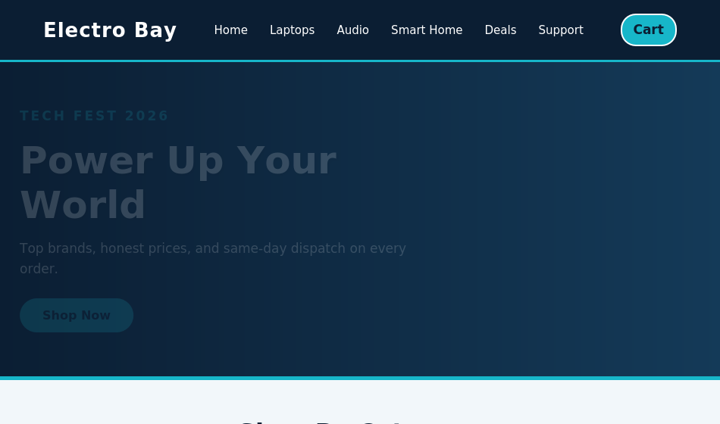
Figure 3.1 Output Page
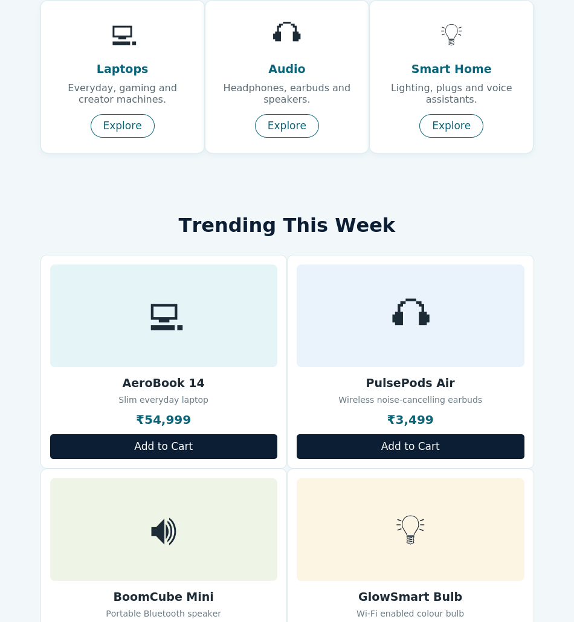
Figure 3.2 Output Page (continued)

Question – 04
Scenario: A fitness studio wants to automate its client fitness assessment process.
Task: Develop a JavaScript program that accepts scores for five fitness areas and displays the Total, Average, Fitness Level, and Program Readiness status. The solution should demonstrate: • Variables and Data Types • Literals • Operators • Statements (Selection and Iteration) • User-defined Functions
Code:
index.html:
<!DOCTYPE html>
<html lang="en">
<head>
<meta charset="UTF-8">
<meta name="viewport" content="width=device-width, initial-scale=1.0">
<title>Fitness Assessment Calculator</title>
<link rel="stylesheet" href="style.css">
</head>
<body>
<header>
<div class="logo">PeakForm</div>
<p>Client Fitness Assessment System</p>
</header>
<main class="container">
<div class="title">
<h1>Fitness Assessment Calculator</h1>
<p>Enter scores for five fitness areas to determine the client's overall fitness level.</p>
</div>

<div class="card">
<h2>Client Information</h2>
<div class="emp-info">
<div>
<label for="clientName">Client Name</label>
<input type="text" id="clientName" placeholder="Enter client name">
</div>
<div>
<label for="clientId">Client ID</label>
<input type="text" id="clientId" placeholder="Enter client ID">
</div>
</div>

<h2>Fitness Test Scores (out of 100)</h2>
<div class="subjects">
<div class="subject">
<label for="score1">Cardiovascular Endurance</label>
<input type="number" id="score1" min="0" max="100" placeholder="0 - 100">
</div>
<div class="subject">
<label for="score2">Muscular Strength</label>
<input type="number" id="score2" min="0" max="100" placeholder="0 - 100">
</div>
<div class="subject">
<label for="score3">Flexibility</label>
<input type="number" id="score3" min="0" max="100" placeholder="0 - 100">
</div>
<div class="subject">
<label for="score4">Balance & Coordination</label>
<input type="number" id="score4" min="0" max="100" placeholder="0 - 100">
</div>
<div class="subject">
<label for="score5">Body Composition</label>
<input type="number" id="score5" min="0" max="100" placeholder="0 - 100">
</div>
</div>

<div id="error"></div>
<div class="buttons">
<button onclick="calculateFitness()">Calculate Result</button>
<button class="reset" onclick="resetForm()">Reset</button>
</div>
</div>

<div class="result-card" id="result">
<h2>Assessment Summary</h2>
<div class="emp-result">
<p>Client: <strong id="resultName">-</strong></p>
<p>ID: <strong id="resultId">-</strong></p>
</div>
<div class="result-container">
<div class="result-box">
<span>Total Score</span>
<strong id="total">0</strong>
<small>/ 500</small>
</div>
<div class="result-box">
<span>Average</span>
<strong id="average">0</strong>
<small>%</small>
</div>
<div class="result-box">
<span>Fitness Level</span>
<strong id="tier">-</strong>
</div>
<div class="result-box status-box">
<span>Program Ready</span>
<strong id="status">-</strong>
</div>
</div>
<div class="bonus-amount">
Recommended Program: <strong id="programName">-</strong>
</div>
</div>
</main>
<footer>
<p>Fitness Assessment Calculator | JavaScript Application</p>
</footer>
<script src="script.js"></script>
</body>
</html>

style.css:
* { box-sizing: border-box; margin: 0; padding: 0; }
body { font-family: Arial, sans-serif; background-color: #fbf5f0; color: #2b2723; }
header {
background-color: #2b2723;
color: white;
padding: 20px 8%;
display: flex;
justify-content: space-between;
align-items: center;
border-bottom: 3px solid #e8641f;
}
.logo { font-size: 24px; font-weight: bold; }
header p { font-size: 14px; }
.container { width: 90%; max-width: 900px; margin: 35px auto; }
.title { text-align: center; margin-bottom: 25px; }
.title h1 { color: #2b2723; margin-bottom: 8px; }
.title p { color: #77706a; }

.card, .result-card {
background-color: white;
padding: 30px;
border-radius: 12px;
box-shadow: 0 4px 15px rgba(0,0,0,0.08);
margin-bottom: 25px;
}
.card h2, .result-card h2 {
color: #2b2723;
margin-bottom: 20px;
border-left: 4px solid #e8641f;
padding-left: 10px;
}
.emp-info { display: flex; gap: 20px; margin-bottom: 30px; }
.emp-info > div { flex: 1; }
label { display: block; font-weight: bold; margin-bottom: 7px; }
input {
width: 100%;
padding: 12px;
border: 1px solid #d8d0c8;
border-radius: 6px;
font-size: 14px;
}
input:focus { outline: none; border-color: #e8641f; box-shadow: 0 0 4px rgba(232,100,31,0.3); }
.subjects { display: flex; flex-wrap: wrap; gap: 20px; }
.subjects .subject { flex: 1 1 45%; }
.buttons { text-align: center; margin-top: 25px; }
button {
padding: 12px 25px;
border: none;
border-radius: 6px;
background-color: #2b2723;
color: white;
font-size: 15px;
cursor: pointer;
margin: 5px;
}
button:hover { background-color: #171512; }
button.reset { background-color: #999; }
button.reset:hover { background-color: #777; }
#error { color: #c0392b; text-align: center; margin-top: 15px; font-weight: bold; }

.result-card { display: none; }
.emp-result {
background-color: #fbf5f0;
padding: 15px;
border-radius: 6px;
margin-bottom: 20px;
display: flex;
justify-content: space-between;
}
.result-container { display: flex; flex-wrap: wrap; gap: 15px; }
.result-container .result-box { flex: 1 1 20%; }
.result-box {
background-color: #fdece0;
border: 1px solid #f6cfae;
border-radius: 8px;
padding: 20px 10px;
text-align: center;
}
.result-box span { display: block; color: #77706a; font-size: 14px; margin-bottom: 10px; }
.result-box strong { color: #2b2723; font-size: 26px; }
.result-box small { color: #77706a; }
.status-box strong { color: #198754; }
.bonus-amount {
text-align: center;
margin-top: 20px;
padding: 16px;
background-color: #eaf6ee;
border-radius: 8px;
font-size: 18px;
color: #157347;
}
footer {
background-color: #2b2723;
color: white;
text-align: center;
padding: 18px;
margin-top: 40px;
}
@media screen and (max-width: 700px) {
header { flex-direction: column; gap: 8px; text-align: center; }
.emp-info, .subjects { flex-direction: column; }
.result-container .result-box { flex: 1 1 45%; }
.emp-result { flex-direction: column; gap: 8px; }
}

script.js:
function calculateTotal(scores) {
let total = 0;
for (let i = 0; i < scores.length; i++) {
total = total + scores[i];
}
return total;
}

function calculateAverage(total) {
return total / 5;
}

function calculateFitnessLevel(average) {
if (average >= 90) {
return "Elite";
} else if (average >= 80) {
return "Advanced";
} else if (average >= 70) {
return "Intermediate";
} else if (average >= 60) {
return "Developing";
} else if (average >= 50) {
return "Beginner";
} else {
return "Needs Foundation Work";
}
}

function checkProgramReady(scores) {
for (let i = 0; i < scores.length; i++) {
if (scores[i] < 35) {
return "Not Ready";
}
}
return "Ready";
}

function recommendProgram(level, readiness) {
if (readiness == "Not Ready") {
return "Foundational Recovery & Mobility Plan";
}
if (level == "Elite" || level == "Advanced") {
return "Performance Strength Program";
} else if (level == "Intermediate") {
return "Balanced Strength & Cardio Program";
} else {
return "Beginner Fitness Building Program";
}
}

function calculateFitness() {
let clientName = document.getElementById("clientName").value;
let clientId = document.getElementById("clientId").value;
let scores = [];
let error = document.getElementById("error");

if (clientName == "" || clientId == "") {
error.innerHTML = "Please enter client name and ID.";
return;
}

for (let i = 1; i <= 5; i++) {
let score = Number(document.getElementById("score" + i).value);
if (score < 0 || score > 100 || document.getElementById("score" + i).value == "") {
error.innerHTML = "Please enter valid scores between 0 and 100.";
return;
}
scores.push(score);
}

error.innerHTML = "";

let total = calculateTotal(scores);
let average = calculateAverage(total);
let tier = calculateFitnessLevel(average);
let status = checkProgramReady(scores);
let program = recommendProgram(tier, status);

document.getElementById("resultName").innerHTML = clientName;
document.getElementById("resultId").innerHTML = clientId;
document.getElementById("total").innerHTML = total;
document.getElementById("average").innerHTML = average.toFixed(2);
document.getElementById("tier").innerHTML = tier;
document.getElementById("status").innerHTML = status;
document.getElementById("programName").innerHTML = program;
document.getElementById("result").style.display = "block";

if (status == "Not Ready") {
document.getElementById("status").style.color = "#c0392b";
} else {
document.getElementById("status").style.color = "#198754";
}
}

function resetForm() {
document.getElementById("clientName").value = "";
document.getElementById("clientId").value = "";
for (let i = 1; i <= 5; i++) {
document.getElementById("score" + i).value = "";
}
document.getElementById("error").innerHTML = "";
document.getElementById("result").style.display = "none";
}

Output:
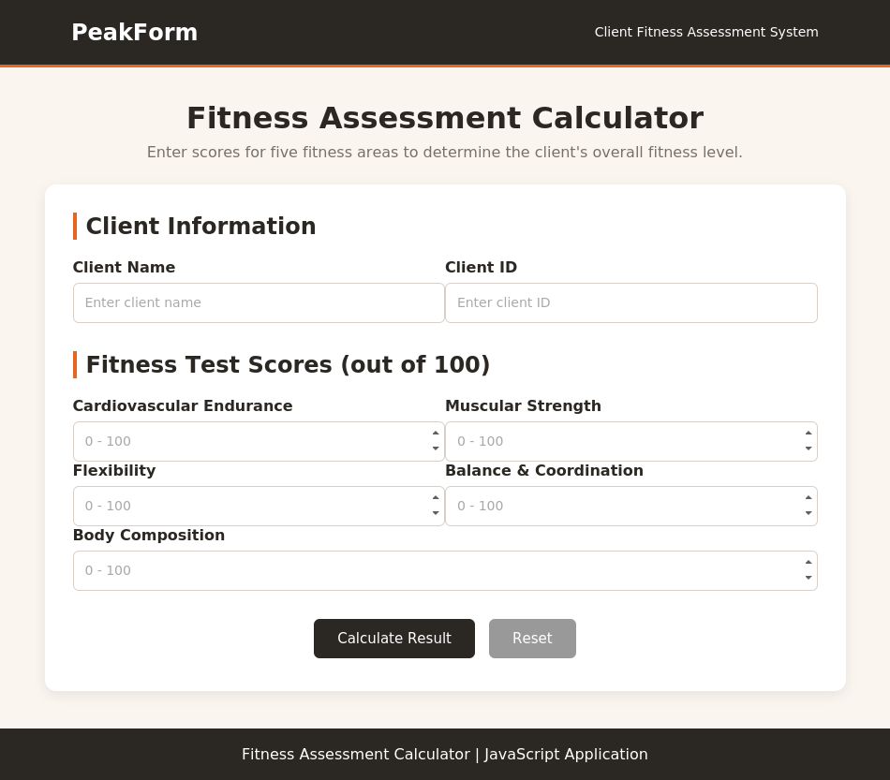
Figure 4.1 Output Page (empty form)
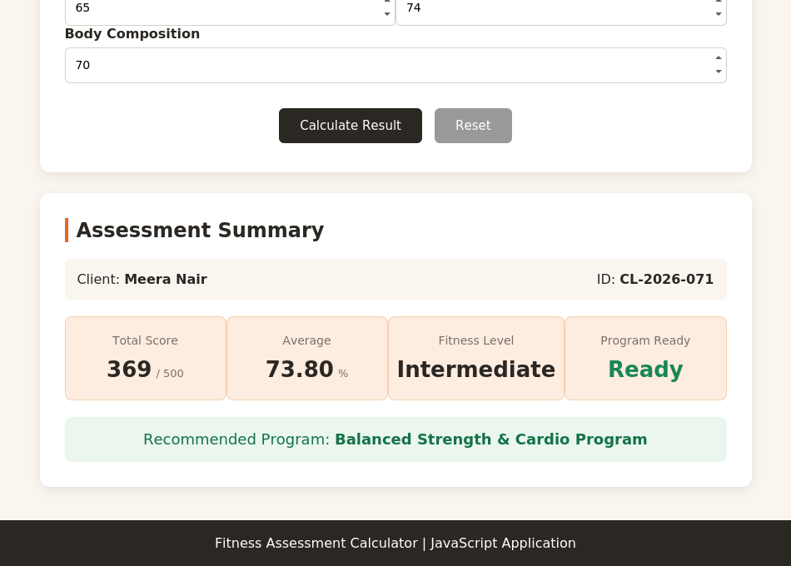
Figure 4.2 Output Page (calculated result)

Question – 05
Scenario: A hardware store wants to generate customer invoices automatically.
Task: Develop a JavaScript program to calculate the invoice amount for three purchased items. The program should: • Accept quantity and unit price for each item • Calculate the subtotal • Apply a 7% bulk purchase discount if the subtotal exceeds ₹3000 • Display the final payable amount. The solution should demonstrate: • Variables and Data Types • Literals • Operators • Statements • User-defined Functions
Code:
index.html:
<!DOCTYPE html>
<html lang="en">
<head>
<meta charset="UTF-8">
<meta name="viewport" content="width=device-width, initial-scale=1.0">
<title>Hardware Store Billing</title>
<link rel="stylesheet" href="style.css">
</head>
<body>
<header>
<div class="logo">BuildRight Hardware</div>
<p>In-Store Billing System</p>
</header>
<main class="container">
<div class="title">
<h1>Customer Invoice</h1>
<p>Enter item details to generate the invoice.</p>
</div>

<div class="card">
<h2>Item Details</h2>

<div class="product">
<div class="product-number">01</div>
<div class="product-details">
<label for="item1">Item Name</label>
<input type="text" id="item1" placeholder="Enter item name">
</div>
<div class="product-details">
<label for="qty1">Quantity</label>
<input type="number" id="qty1" min="1" placeholder="0">
</div>
<div class="product-details">
<label for="price1">Unit Price (&#8377;)</label>
<input type="number" id="price1" min="0" step="0.01" placeholder="0.00">
</div>
</div>

<div class="product">
<div class="product-number">02</div>
<div class="product-details">
<label for="item2">Item Name</label>
<input type="text" id="item2" placeholder="Enter item name">
</div>
<div class="product-details">
<label for="qty2">Quantity</label>
<input type="number" id="qty2" min="1" placeholder="0">
</div>
<div class="product-details">
<label for="price2">Unit Price (&#8377;)</label>
<input type="number" id="price2" min="0" step="0.01" placeholder="0.00">
</div>
</div>

<div class="product">
<div class="product-number">03</div>
<div class="product-details">
<label for="item3">Item Name</label>
<input type="text" id="item3" placeholder="Enter item name">
</div>
<div class="product-details">
<label for="qty3">Quantity</label>
<input type="number" id="qty3" min="1" placeholder="0">
</div>
<div class="product-details">
<label for="price3">Unit Price (&#8377;)</label>
<input type="number" id="price3" min="0" step="0.01" placeholder="0.00">
</div>
</div>

<div id="error"></div>
<div class="buttons">
<button onclick="generateInvoice()">Generate Invoice</button>
<button class="reset" onclick="resetInvoice()">Reset</button>
</div>
</div>

<div class="bill-card" id="bill">
<div class="bill-heading">
<h2>BuildRight Hardware</h2>
<p>Customer Invoice</p>
</div>
<div class="bill-items">
<div class="bill-row bill-header">
<span>Item</span>
<span>Qty</span>
<span>Price</span>
<span>Amount</span>
</div>
<div class="bill-row">
<span id="billItem1">-</span>
<span id="billQty1">0</span>
<span>&#8377;<span id="billPrice1">0</span></span>
<span>&#8377;<span id="amount1">0</span></span>
</div>
<div class="bill-row">
<span id="billItem2">-</span>
<span id="billQty2">0</span>
<span>&#8377;<span id="billPrice2">0</span></span>
<span>&#8377;<span id="amount2">0</span></span>
</div>
<div class="bill-row">
<span id="billItem3">-</span>
<span id="billQty3">0</span>
<span>&#8377;<span id="billPrice3">0</span></span>
<span>&#8377;<span id="amount3">0</span></span>
</div>
</div>
<div class="summary">
<p><span>Subtotal</span><strong>&#8377;<span id="total">0</span></strong></p>
<p><span>Bulk Purchase Discount</span><strong>&#8377;<span id="discount">0</span></strong></p>
<div class="final">
<span>Amount Payable</span>
<strong>&#8377;<span id="finalAmount">0</span></strong>
</div>
</div>
<p class="thank-you">Thank you for shopping at BuildRight Hardware!</p>
</div>
</main>
<footer>
<p>&copy; 2026 BuildRight Hardware | In-Store Billing System</p>
</footer>
<script src="script.js"></script>
</body>
</html>

style.css:
* { box-sizing: border-box; margin: 0; padding: 0; }
body { font-family: Arial, sans-serif; background-color: #f2f2f0; color: #2c2c2c; }
header {
background-color: #3a3f44;
color: white;
padding: 20px 8%;
display: flex;
justify-content: space-between;
align-items: center;
border-bottom: 3px solid #f2b705;
}
.logo { font-size: 25px; font-weight: bold; }
header p { font-size: 14px; }
.container { width: 90%; max-width: 950px; margin: 35px auto; }
.title { text-align: center; margin-bottom: 25px; }
.title h1 { color: #3a3f44; margin-bottom: 8px; }
.title p { color: #777; }

.card, .bill-card {
background-color: white;
padding: 30px;
border-radius: 12px;
box-shadow: 0 4px 15px rgba(0,0,0,0.08);
margin-bottom: 25px;
}
.card h2 {
color: #3a3f44;
margin-bottom: 20px;
border-left: 4px solid #f2b705;
padding-left: 10px;
}
.product {
display: flex;
gap: 15px;
align-items: flex-end;
padding: 18px;
margin-bottom: 15px;
background-color: #fafafa;
border: 1px solid #e2e2e2;
border-radius: 8px;
}
.product-number {
background-color: #3a3f44;
color: white;
width: 35px;
height: 35px;
border-radius: 50%;
display: flex;
align-items: center;
justify-content: center;
font-weight: bold;
flex: 0 0 35px;
}
.product-details { flex: 1; }
.product-details:first-of-type { flex: 2; }
.product-details label { display: block; font-weight: bold; margin-bottom: 7px; }
input {
width: 100%;
padding: 11px;
border: 1px solid #ccc;
border-radius: 5px;
font-size: 14px;
}
input:focus { outline: none; border-color: #f2b705; }
#error { color: #c0392b; text-align: center; font-weight: bold; margin: 15px 0; }
.buttons { text-align: center; margin-top: 20px; }
button {
padding: 12px 28px;
border: none;
border-radius: 6px;
background-color: #3a3f44;
color: white;
font-size: 15px;
cursor: pointer;
margin: 5px;
}
button:hover { background-color: #24282b; }
button.reset { background-color: #888; }
button.reset:hover { background-color: #666; }

.bill-card { display: none; }
.bill-heading {
text-align: center;
border-bottom: 2px solid #3a3f44;
padding-bottom: 15px;
margin-bottom: 15px;
}
.bill-heading h2 { color: #3a3f44; font-size: 26px; }
.bill-heading p { color: #777; }
.bill-row {
display: flex;
padding: 13px 5px;
border-bottom: 1px solid #eee;
}
.bill-row span { flex: 1; text-align: center; }
.bill-row span:first-child { flex: 2; text-align: left; }
.bill-header { background-color: #3a3f44; color: white; font-weight: bold; }
.summary { width: 340px; max-width: 100%; margin: 25px 0 0 auto; }
.summary p { display: flex; justify-content: space-between; padding: 8px 0; }
.final {
display: flex;
justify-content: space-between;
background-color: #fdf3d3;
color: #3a3f44;
padding: 15px;
margin-top: 10px;
border-radius: 6px;
font-size: 18px;
font-weight: bold;
}
.thank-you { text-align: center; margin-top: 25px; color: #777; }
footer {
background-color: #3a3f44;
color: white;
text-align: center;
padding: 18px;
margin-top: 40px;
}
@media screen and (max-width: 700px) {
header { flex-direction: column; gap: 8px; text-align: center; }
.product { flex-wrap: wrap; }
.bill-row { font-size: 13px; }
}

script.js:
function calculateAmount(quantity, price) {
return quantity * price;
}

function calculateTotal(amounts) {
let total = 0;
for (let i = 0; i < amounts.length; i++) {
total = total + amounts[i];
}
return total;
}

function calculateDiscount(total) {
if (total > 3000) {
return total * 0.07;
} else {
return 0;
}
}

function generateInvoice() {
let quantities = [];
let prices = [];
let amounts = [];
let error = document.getElementById("error");

for (let i = 1; i <= 3; i++) {
let quantity = Number(document.getElementById("qty" + i).value);
let price = Number(document.getElementById("price" + i).value);

if (quantity <= 0 || price < 0 || document.getElementById("qty" + i).value == "" || document.getElementById("price" + i).value == "") {
error.innerHTML = "Please enter valid quantity and price for all items.";
return;
}

quantities.push(quantity);
prices.push(price);
amounts.push(calculateAmount(quantity, price));
}

error.innerHTML = "";

let total = calculateTotal(amounts);
let discount = calculateDiscount(total);
let finalAmount = total - discount;

for (let i = 1; i <= 3; i++) {
let itemName = document.getElementById("item" + i).value;
if (itemName == "") {
itemName = "Item " + i;
}
document.getElementById("billItem" + i).innerHTML = itemName;
document.getElementById("billQty" + i).innerHTML = quantities[i - 1];
document.getElementById("billPrice" + i).innerHTML = prices[i - 1].toFixed(2);
document.getElementById("amount" + i).innerHTML = amounts[i - 1].toFixed(2);
}

document.getElementById("total").innerHTML = total.toFixed(2);
document.getElementById("discount").innerHTML = discount.toFixed(2);
document.getElementById("finalAmount").innerHTML = finalAmount.toFixed(2);
document.getElementById("bill").style.display = "block";
}

function resetInvoice() {
for (let i = 1; i <= 3; i++) {
document.getElementById("item" + i).value = "";
document.getElementById("qty" + i).value = "";
document.getElementById("price" + i).value = "";
}
document.getElementById("error").innerHTML = "";
document.getElementById("bill").style.display = "none";
}

Output:
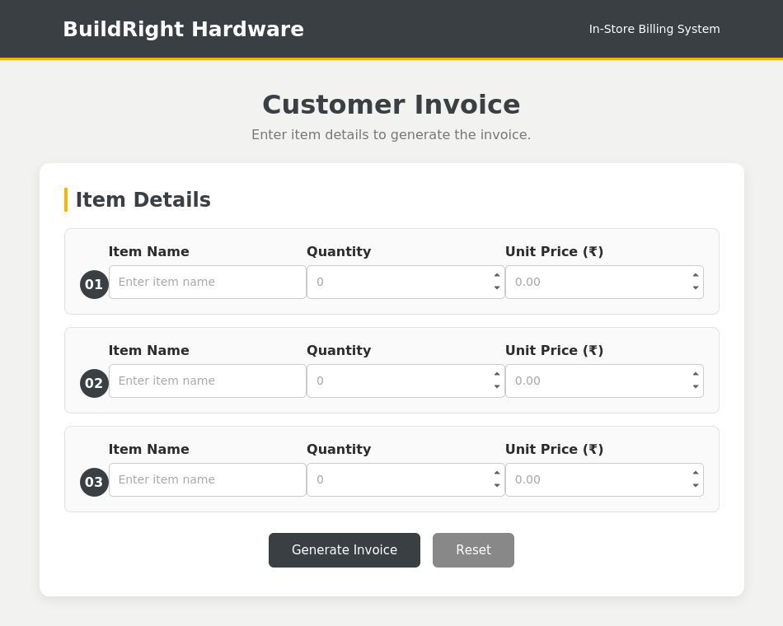
Figure 5.1 Output Page (empty invoice)
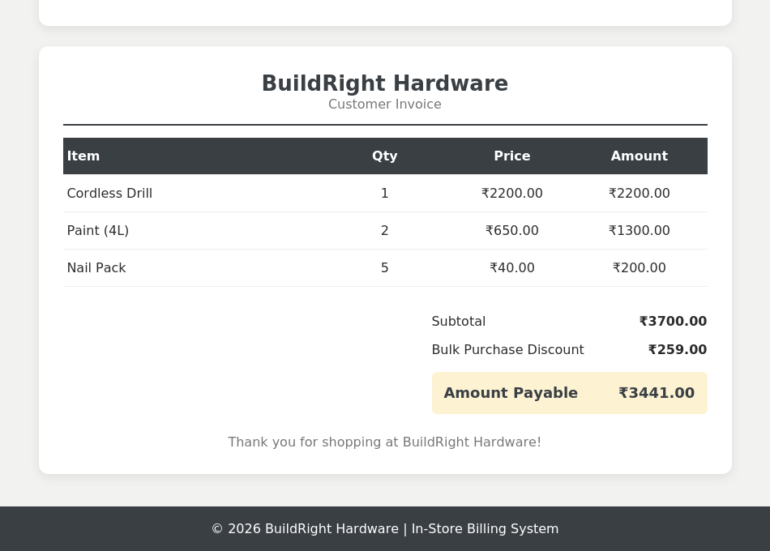
Figure 5.2 Output Page (generated invoice)

